Circular Curvilinear Shapes
# Source: AI Source: Provided by: [Data Path: Persons Table -> ID Column: 1, Name_En Column: Motasem Essam] -> From: [ChatGPT] on [7/25/2026]
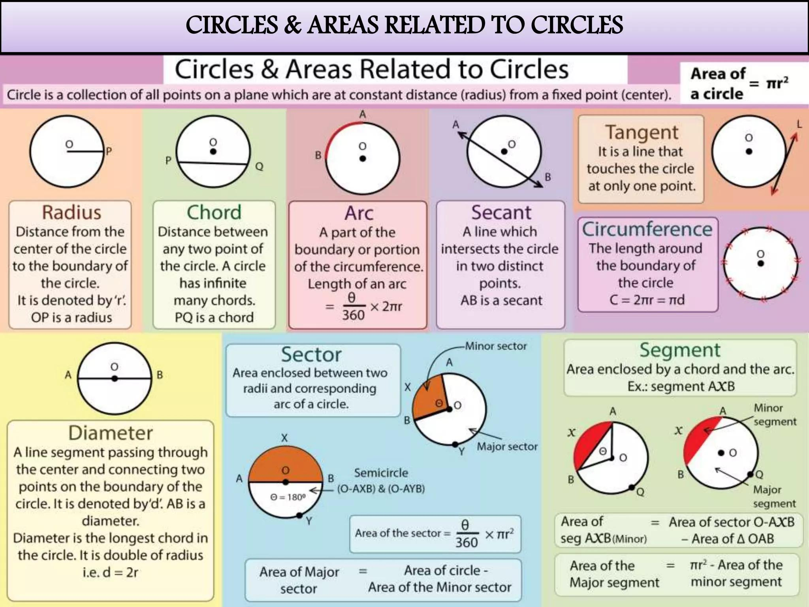
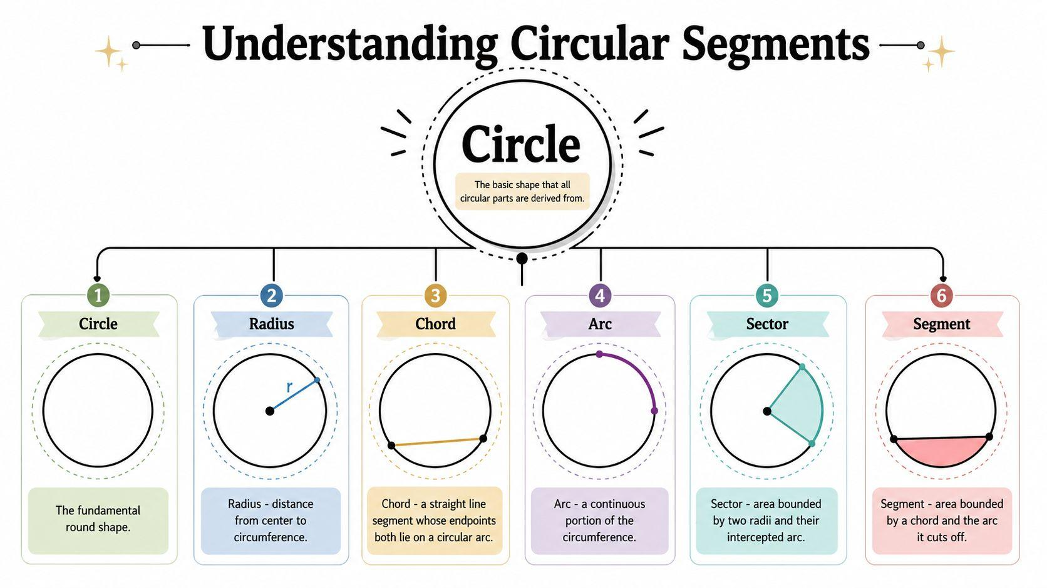
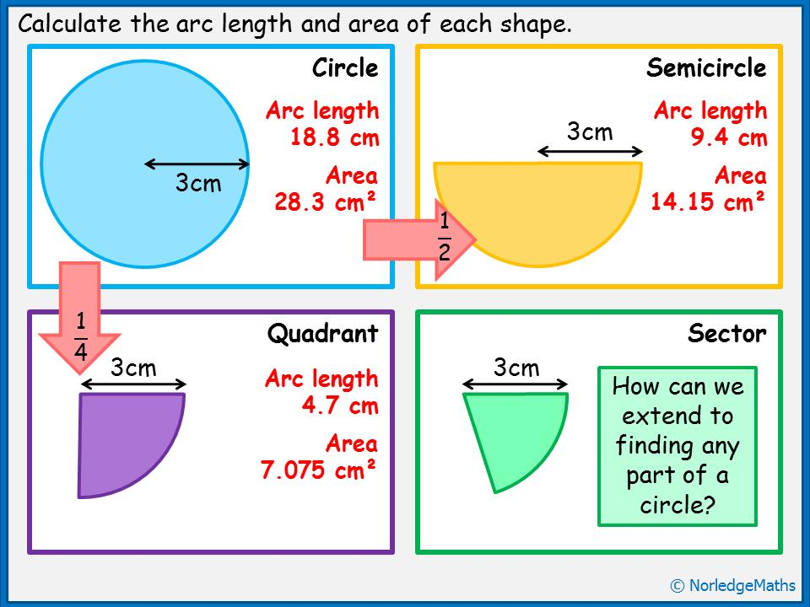

Definition
# Source: AI Source: Provided by: [Data Path: Persons Table -> ID Column: 1, Name_En Column: Motasem Essam] -> From: [ChatGPT] on [7/25/2026]
Circular Curvilinear Shapes are shapes whose curved boundaries are formed by circles or circular arcs.
They are a specific type of Curvilinear Shape in which the relevant curves have constant curvature and a common circular geometry.
Circular curvilinear shapes may consist of:
- Complete circles
- Circular arcs
- Multiple circular arcs
- Circular sectors
- Circular segments
- Annular regions
- Regions bounded by combinations of circular arcs and straight segments
The defining property is the presence of circular curves as boundary elements.

Fundamental Concept
# Source: AI Source: Provided by: [Data Path: Persons Table -> ID Column: 1, Name_En Column: Motasem Essam] -> From: [ChatGPT] on [7/25/2026]
A circular curve is defined by a fixed center and a constant radius.
For a circle with center $\left(h , k\right)$and radius $r$:
$${\left(x-h\right)}^{2}+{\left(y-k\right)}^{2}=r^{2}$$
Every point on the circle is exactly $r$units from the center.
Therefore, a circular curvilinear boundary has constant curvature:
$$κ=\frac{1}{r}$$
This distinguishes circular curves from many other curves whose curvature changes from point to point.

Main Characteristics
# Source: AI Source: Provided by: [Data Path: Persons Table -> ID Column: 1, Name_En Column: Motasem Essam] -> From: [ChatGPT] on [7/25/2026]
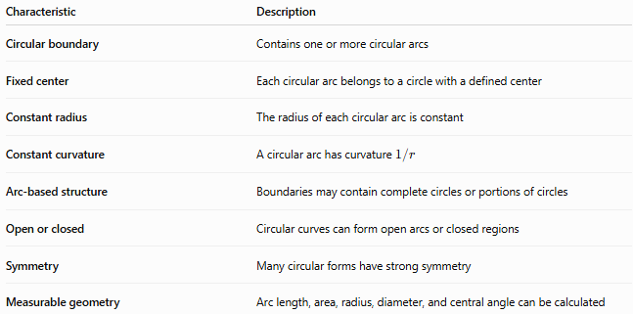
Characteristic | Description
Circular boundary | Contains one or more circular arcs
Fixed center | Each circular arc belongs to a circle with a defined center
Constant radius | The radius of each circular arc is constant
Constant curvature | A circular arc has curvature $1/r$
Arc-based structure | Boundaries may contain complete circles or portions of circles
Open or closed | Circular curves can form open arcs or closed regions
Symmetry | Many circular forms have strong symmetry
Measurable geometry | Arc length, area, radius, diameter, and central angle can be calculated

Basic Structure
# Source: AI Source: Provided by: [Data Path: Persons Table -> ID Column: 1, Name_En Column: Motasem Essam] -> From: [ChatGPT] on [7/25/2026]
Circular Curvilinear Shapes can be organized as:
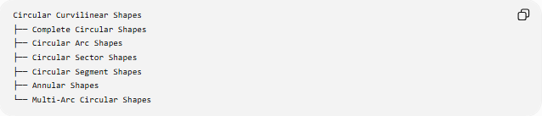
Circular Curvilinear Shapes
├── Complete Circular Shapes
├── Circular Arc Shapes
├── Circular Sector Shapes
├── Circular Segment Shapes
├── Annular Shapes
└── Multi-Arc Circular Shapes
Some of these shapes also contain straight boundaries.
For example:
- A circular sector has two radii and one circular arc.
- A circular segment has one chord and one circular arc.
- An annulus is bounded by two concentric circles.

Types of Circular Curvilinear Shapes

1-Complete Circular Shapes
# Source: AI Source: Provided by: [Data Path: Persons Table -> ID Column: 1, Name_En Column: Motasem Essam] -> From: [ChatGPT] on [7/25/2026]
A complete circle is the simplest closed circular curvilinear shape.
Its equation is:
$${\left(x-h\right)}^{2}+{\left(y-k\right)}^{2}=r^{2}$$
Its circumference is:
$$C=2πr$$
and its area is:
$$A=πr^{2}$$
A circle has infinitely many lines of reflection symmetry and rotational symmetry through every angle.

2-Circular Arc Shapes
# Source: AI Source: Provided by: [Data Path: Persons Table -> ID Column: 1, Name_En Column: Motasem Essam] -> From: [ChatGPT] on [7/25/2026]
A circular arc is a portion of the circumference of a circle.
An arc is defined by:
- Center
- Radius
- Starting point
- Ending point
- Central angle
For central angle $θ$measured in radians:
$$L=rθ$$
If $θ$is measured in degrees:
$$L=\frac{θ}{{360}^{∘}}\left(2πr\right)$$
Circular arcs may be:
- Minor arcs
- Semicircular arcs
- Major arcs

3-Circular Sector Shapes
# Source: AI Source: Provided by: [Data Path: Persons Table -> ID Column: 1, Name_En Column: Motasem Essam] -> From: [ChatGPT] on [7/25/2026]
A circular sector is a region bounded by:
- Two radii
- One circular arc
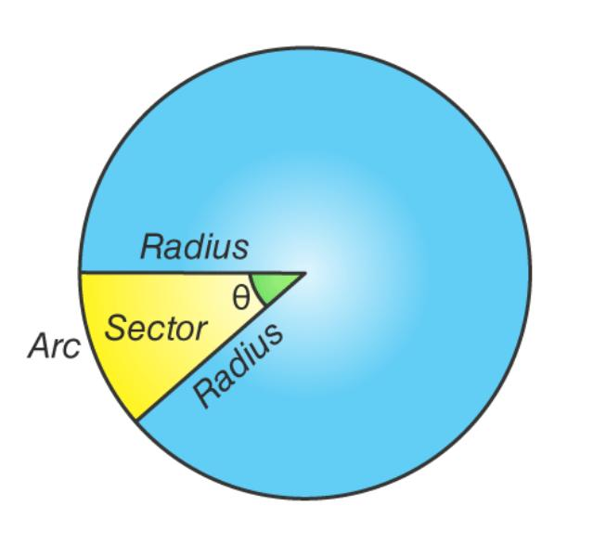
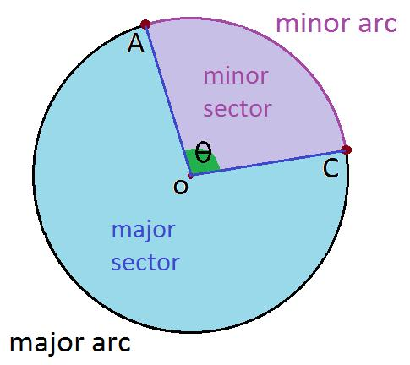
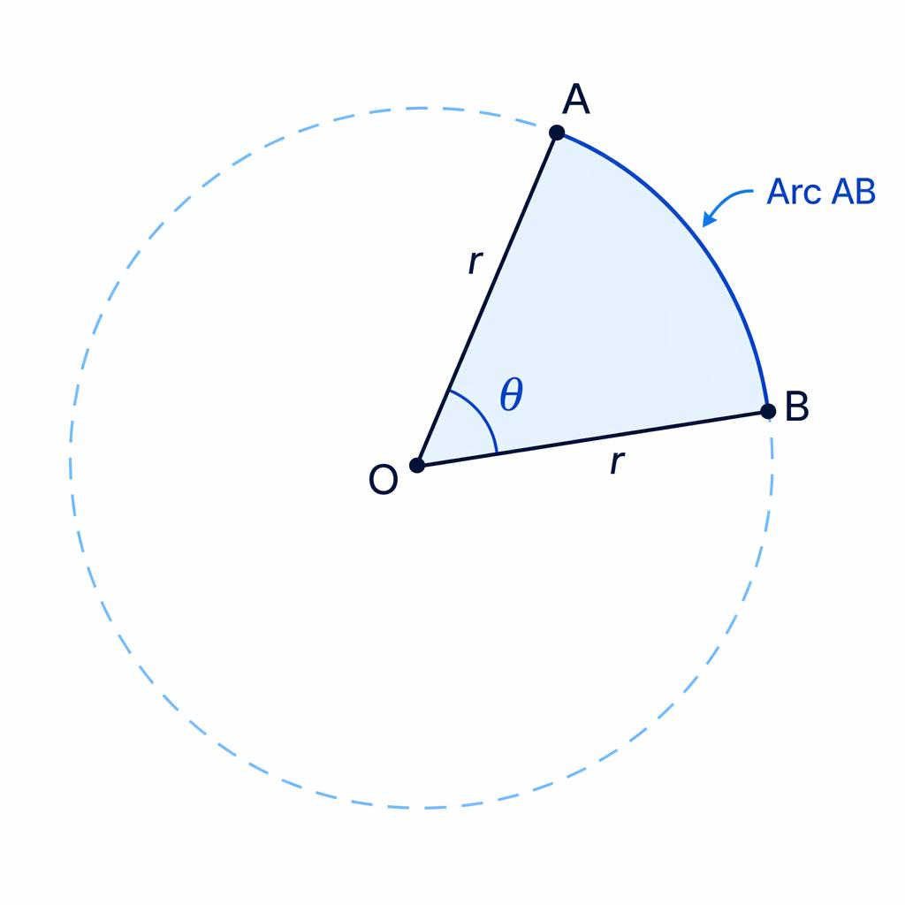
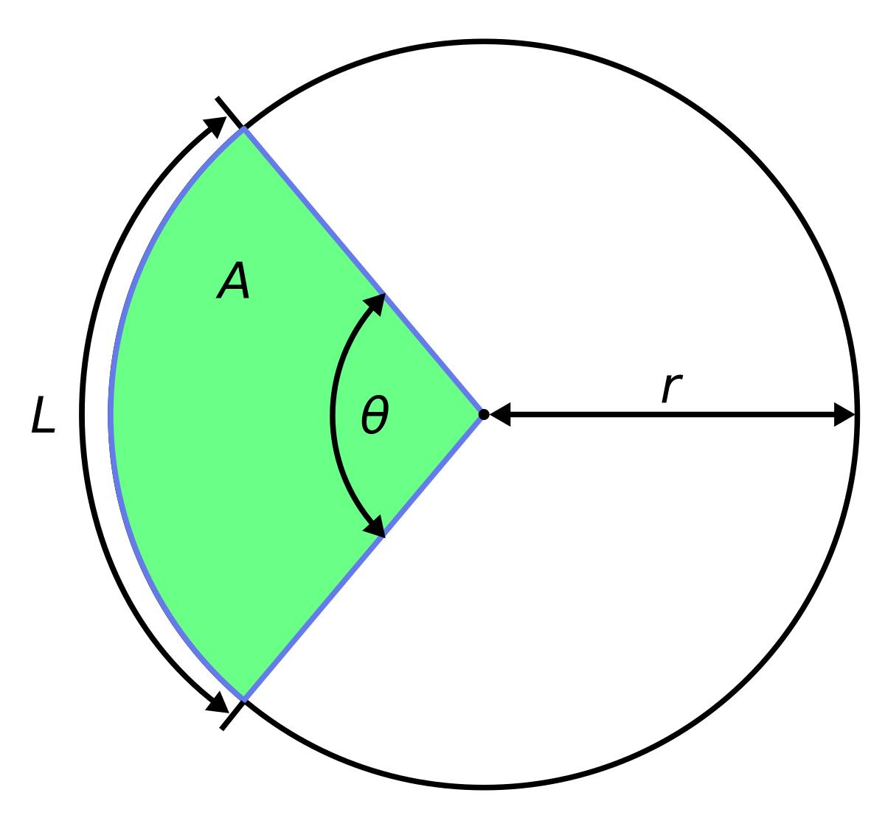
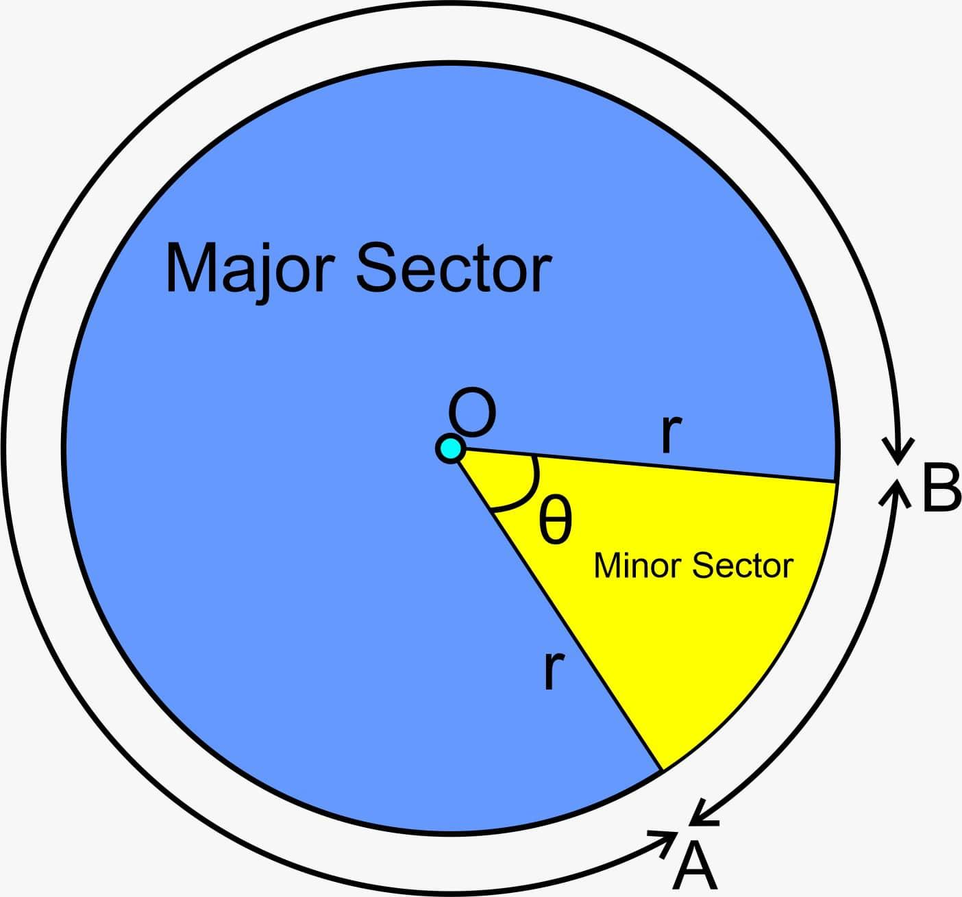
For central angle $θ$in radians:
$$A=\frac{1}{2}r^{2}θ$$
Its arc length is:
$$L=rθ$$
Its perimeter is:
$$P=2r+rθ$$
A sector can be classified as:
- Minor sector
- Semicircular sector
- Major sector

4-Circular Segment Shapes
# Source: AI Source: Provided by: [Data Path: Persons Table -> ID Column: 1, Name_En Column: Motasem Essam] -> From: [ChatGPT] on [7/25/2026]
A circular segment is a region bounded by:
- A circular arc
- A chord
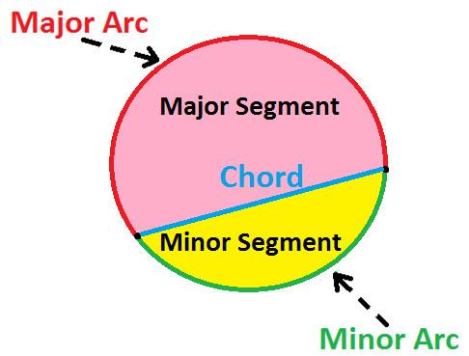
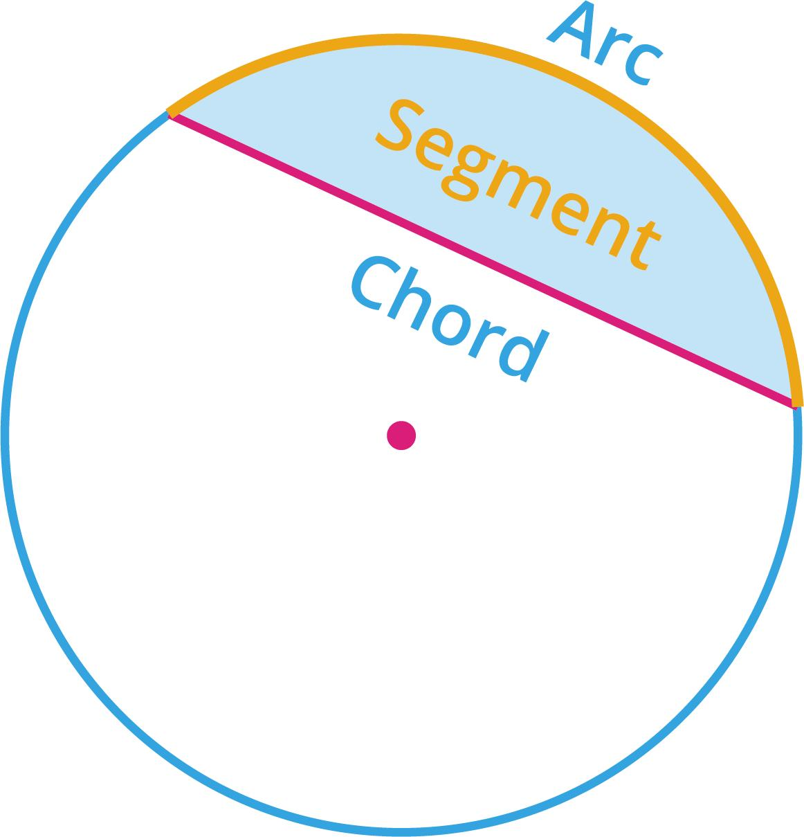
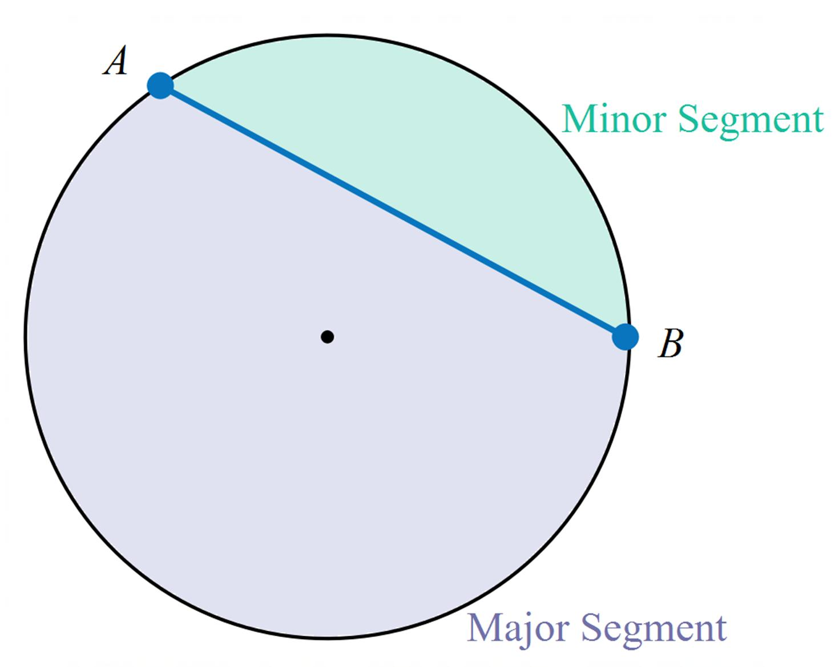
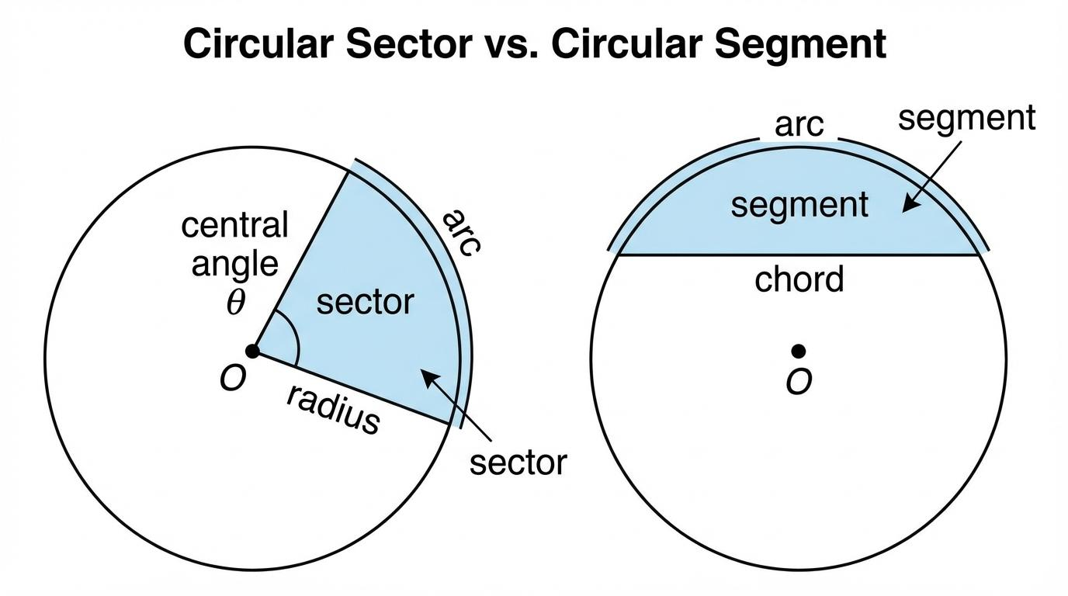
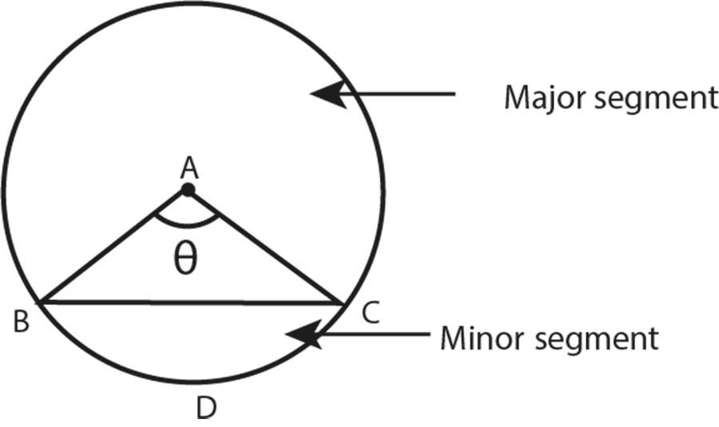
For a segment with central angle $θ$in radians:
$$A_{\text{segment}}=\frac{1}{2}r^{2}\left(θ-\sin{θ}\right)$$
The segment can be classified as:
- Minor segment
- Major segment
The chord length is:
$$c=2r\sin\left(\frac{θ}{2}\right)$$

5-Annular Shapes
# Source: AI Source: Provided by: [Data Path: Persons Table -> ID Column: 1, Name_En Column: Motasem Essam] -> From: [ChatGPT] on [7/25/2026]
An annulus is the region between two concentric circles.
If:
- $R$= outer radius
- $r$= inner radius
then:
$$R>r$$
The annular area is:
$$A=π\left(R^{2}-r^{2}\right)$$
The radial thickness is:
$$t=R-r$$
An annulus is therefore a circular curvilinear region bounded entirely by circular curves.

6-Multi-Arc Circular Shapes
# Source: AI Source: Provided by: [Data Path: Persons Table -> ID Column: 1, Name_En Column: Motasem Essam] -> From: [ChatGPT] on [7/25/2026]
Some shapes are bounded by two or more circular arcs, potentially with different centers or radii.
For example:
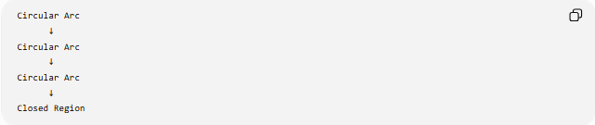
Circular Arc
↓
Circular Arc
↓
Circular Arc
↓
Closed Region
These are useful for constructing:
- Rounded shapes
- Curved mechanical profiles
- Decorative forms
- Composite circular regions
If different arcs belong to different circles, each arc has its own:
$$O_{i}, r_{i}$$
where $O_{i}$is its center and $r_{i}$is its radius.

Circular Curvilinear Shapes by Boundary Type
# Source: AI Source: Provided by: [Data Path: Persons Table -> ID Column: 1, Name_En Column: Motasem Essam] -> From: [ChatGPT] on [7/25/2026]
Another useful classification is based on the boundary.
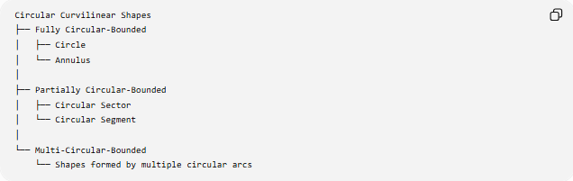
Circular Curvilinear Shapes
├── Fully Circular-Bounded
│ ├── Circle
│ └── Annulus
│
├── Partially Circular-Bounded
│ ├── Circular Sector
│ └── Circular Segment
│
└── Multi-Circular-Bounded
└── Shapes formed by multiple circular arcs
This classification is particularly useful because some circular curvilinear shapes contain both curved and straight boundaries.

Circular Curvilinear Shapes with Straight Boundaries
# Source: AI Source: Provided by: [Data Path: Persons Table -> ID Column: 1, Name_En Column: Motasem Essam] -> From: [ChatGPT] on [7/25/2026]
Not every circular curvilinear shape has a completely curved boundary.
For example:
Circular Sector
$$\text{2 straight radii}+\text{1 circular arc}$$
Circular Segment
$$\text{1 straight chord}+\text{1 circular arc}$$
Therefore:
Circular curvilinear refers to the circular nature of the curved boundary; it does not necessarily mean that every part of the boundary is curved.

Central Angle
# Source: AI Source: Provided by: [Data Path: Persons Table -> ID Column: 1, Name_En Column: Motasem Essam] -> From: [ChatGPT] on [7/25/2026]
The central angle determines the size of a circular arc or sector.
For a circle of radius $r$, arc length is:
$$L=rθ$$
where $θ$is in radians.
The corresponding sector area is:
$$A=\frac{1}{2}r^{2}θ$$
Thus, the central angle connects:
$$\text{Radius}⟶\text{Arc Length}⟶\text{Sector Area}$$

Circular Arc Length
# Source: AI Source: Provided by: [Data Path: Persons Table -> ID Column: 1, Name_En Column: Motasem Essam] -> From: [ChatGPT] on [7/25/2026]
For an arc subtending angle $θ$:
Radians
$$L=rθ$$
Degrees
$$L=\frac{θ}{{360}^{∘}}\left(2πr\right)$$
For a complete circle:
$$θ=2π$$
so:
$$L=2πr$$

Curvature
# Source: AI Source: Provided by: [Data Path: Persons Table -> ID Column: 1, Name_En Column: Motasem Essam] -> From: [ChatGPT] on [7/25/2026]
Every circular arc belonging to a circle of radius $r$has constant curvature:
$$\boxed{κ=\frac{1}{r}}$$
Therefore:
- Smaller radius → greater curvature
- Larger radius → smaller curvature
For two circular arcs:
$$r_{1}<r_{2}$$
then:
$$κ_{1}>κ_{2}$$
This constant-curvature property is one of the most important mathematical characteristics of circular curves.

Symmetry
# Source: AI Source: Provided by: [Data Path: Persons Table -> ID Column: 1, Name_En Column: Motasem Essam] -> From: [ChatGPT] on [7/25/2026]
Circular Curvilinear Shapes often have strong symmetry.
Circle
A circle has:
- Infinitely many reflection axes
- Rotational symmetry through every angle
Semicircle
A semicircle has one principal reflection axis.
Circular sector
A sector generally has reflection symmetry along the bisector of its central angle when its boundary is considered as a complete sector.
Annulus
An annulus has:
- Infinitely many reflection axes
- Continuous rotational symmetry
Symmetry depends on the specific circular shape rather than simply on the fact that it is circular.

Mathematical Representation
# Source: AI Source: Provided by: [Data Path: Persons Table -> ID Column: 1, Name_En Column: Motasem Essam] -> From: [ChatGPT] on [7/25/2026]
Cartesian equation
A circle:
$${\left(x-h\right)}^{2}+{\left(y-k\right)}^{2}=r^{2}$$
Parametric equation
$$x=h+r\cos{t} \\ y=k+r\sin{t}$$
or:
$$r\left(t\right)=\left(h , +r\cos{t} k+r\sin{t}\right)$$
where $t$determines the position along the circle.
Polar equation
For a circle centered at the origin:
$$r=R$$

Area and Perimeter
# Source: AI Source: Provided by: [Data Path: Persons Table -> ID Column: 1, Name_En Column: Motasem Essam] -> From: [ChatGPT] on [7/25/2026]
Different circular curvilinear shapes use different formulas.
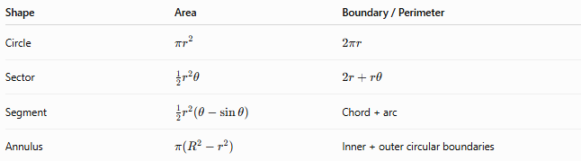
Shape | Area | Boundary / Perimeter
Circle | $$πr^{2}$$ | $$2πr$$
Sector | $$\frac{1}{2}r^{2}θ$$ | $$2r+rθ$$
Segment | $$\frac{1}{2}r^{2}\left(θ-\sin{θ}\right)$$ | Chord + arc
Annulus | $$π\left(R^{2}-r^{2}\right)$$ | Inner + outer circular boundaries
For sector and segment formulas, $θ$is measured in radians unless otherwise stated.

Circular Curvilinear Shapes vs Other Curvilinear Shapes
# Source: AI Source: Provided by: [Data Path: Persons Table -> ID Column: 1, Name_En Column: Motasem Essam] -> From: [ChatGPT] on [7/25/2026]
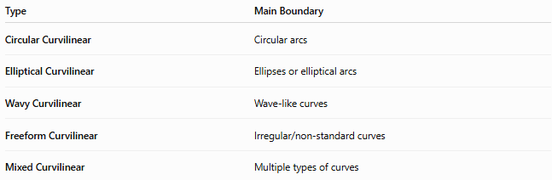
Type | Main Boundary
Circular Curvilinear | Circular arcs
Elliptical Curvilinear | Ellipses or elliptical arcs
Wavy Curvilinear | Wave-like curves
Freeform Curvilinear | Irregular/non-standard curves
Mixed Curvilinear | Multiple types of curves
The defining distinction is the mathematical type of the curve.

Circular Curvilinear Shapes vs Circular Shapes
# Source: AI Source: Provided by: [Data Path: Persons Table -> ID Column: 1, Name_En Column: Motasem Essam] -> From: [ChatGPT] on [7/25/2026]
These terms are related but not identical.
Circular Shape usually refers to a shape directly based on a circle, such as a circle or circular disk.
Circular Curvilinear Shape is broader and emphasizes the use of circular arcs as boundary elements.
For example:
- Circle → circular
- Circular sector → circular curvilinear
- Circular segment → circular curvilinear
- Annulus → circular curvilinear
- Multi-arc region → circular curvilinear

Examples

Example 1 — Circle
# Source: AI Source: Provided by: [Data Path: Persons Table -> ID Column: 1, Name_En Column: Motasem Essam] -> From: [ChatGPT] on [7/25/2026]
A complete circular boundary:
$$C=2πr$$

Example 2 — Semicircle
# Source: AI Source: Provided by: [Data Path: Persons Table -> ID Column: 1, Name_En Column: Motasem Essam] -> From: [ChatGPT] on [7/25/2026]
Half of a circle:
$$θ=π$$

Example 3 — Circular Sector
# Source: AI Source: Provided by: [Data Path: Persons Table -> ID Column: 1, Name_En Column: Motasem Essam] -> From: [ChatGPT] on [7/25/2026]
A region bounded by two radii and an arc.

Example 4 — Circular Segment
# Source: AI Source: Provided by: [Data Path: Persons Table -> ID Column: 1, Name_En Column: Motasem Essam] -> From: [ChatGPT] on [7/25/2026]
A region bounded by a chord and an arc.

Example 5 — Annulus
# Source: AI Source: Provided by: [Data Path: Persons Table -> ID Column: 1, Name_En Column: Motasem Essam] -> From: [ChatGPT] on [7/25/2026]
The region between two concentric circles.

Example 6 — Multi-Arc Shape
# Source: AI Source: Provided by: [Data Path: Persons Table -> ID Column: 1, Name_En Column: Motasem Essam] -> From: [ChatGPT] on [7/25/2026]
A region constructed from several circular arcs with different centers and radii.

Classification Summary
# Source: AI Source: Provided by: [Data Path: Persons Table -> ID Column: 1, Name_En Column: Motasem Essam] -> From: [ChatGPT] on [7/25/2026]
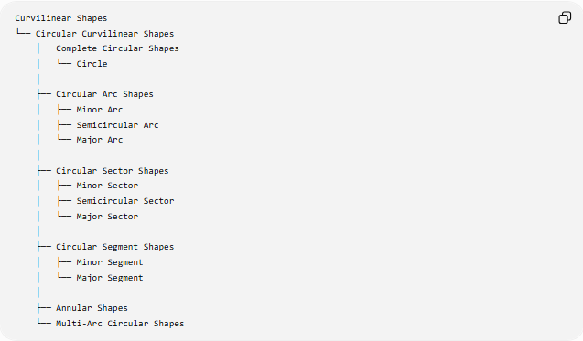
Curvilinear Shapes
└── Circular Curvilinear Shapes
├── Complete Circular Shapes
│ └── Circle
│
├── Circular Arc Shapes
│ ├── Minor Arc
│ ├── Semicircular Arc
│ └── Major Arc
│
├── Circular Sector Shapes
│ ├── Minor Sector
│ ├── Semicircular Sector
│ └── Major Sector
│
├── Circular Segment Shapes
│ ├── Minor Segment
│ └── Major Segment
│
├── Annular Shapes
└── Multi-Arc Circular Shapes
A boundary-based classification is:
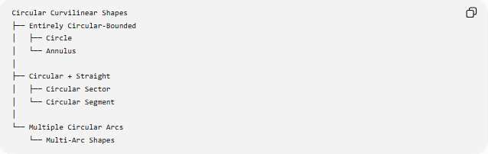
Circular Curvilinear Shapes
├── Entirely Circular-Bounded
│ ├── Circle
│ └── Annulus
│
├── Circular + Straight
│ ├── Circular Sector
│ └── Circular Segment
│
└── Multiple Circular Arcs
└── Multi-Arc Shapes

Key Points
# Source: AI Source: Provided by: [Data Path: Persons Table -> ID Column: 1, Name_En Column: Motasem Essam] -> From: [ChatGPT] on [7/25/2026]
- Circular Curvilinear Shapes are curvilinear shapes whose curved boundaries are based on circles or circular arcs.
- A circular arc has constant curvature:
$$κ=\frac{1}{r}$$
- They include circles, arcs, sectors, segments, annuli, and multi-arc shapes.
- Some have entirely circular boundaries, while others combine circular arcs with straight segments.
- Arc length is:
$$L=rθ$$
when $θ$is measured in radians.
- A sector's area is:
$$A=\frac{1}{2}r^{2}θ$$
- A circular segment's area is:
$$A=\frac{1}{2}r^{2}\left(θ-\sin{θ}\right)$$
- An annulus has area:
$$A=π\left(R^{2}-r^{2}\right)$$
- Circularity does not require the entire boundary to be curved; sectors and segments are important examples.
- The defining mathematical feature is the use of circular curves with constant radius and curvature.

Conclusion
# Source: AI Source: Provided by: [Data Path: Persons Table -> ID Column: 1, Name_En Column: Motasem Essam] -> From: [ChatGPT] on [7/25/2026]
Circular Curvilinear Shapes are a major class of curvilinear shapes formed using circles and circular arcs. They include complete circles, arcs, sectors, segments, annuli, and shapes constructed from multiple circular arcs. Their geometry is characterized by a fixed radius for each circular component and constant curvature along each circular arc.

